**SCRUM Framework:**

**Scrum:**

Scrum is a lightweight, agile framework for developing and delivering complex products. It enables teams to work iteratively and incrementally, fostering continuous improvement and flexibility. Scrum is widely used for managing software development projects but is applicable to many fields.

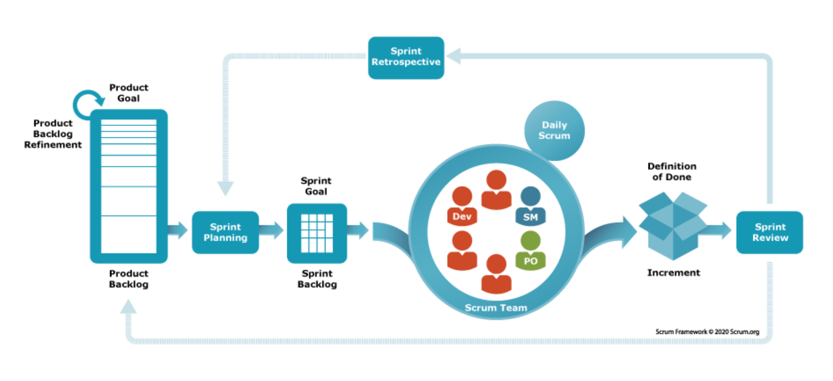

**Scrum Roles:**

Scrum defines three key roles:

* **Product Owner**: Responsible for maximizing product value and managing the Product Backlog.
* **Scrum Master**: Ensures Scrum is understood and enacted. They facilitate the process and remove impediments.
* **Developers**: Professionals who create the product during each Sprint.

**Scrum Artifacts:**

Artifacts are crucial in providing transparency:

* **Product Backlog**:  
  The Product Backlog is a dynamic, prioritized list containing all features, enhancements, technical work, and bug fixes needed to build and improve the product over time. It evolves continuously based on changing requirements, market needs, and stakeholder feedback.
* **Sprint Backlog**:  
  The Sprint Backlog is a specific set of Product Backlog items selected by the team for a particular Sprint, along with a detailed plan outlining how the team will work together to complete these items and achieve the Sprint Goal.
* **Increment**:  
  An Increment is the sum of all completed Product Backlog items during a Sprint, forming a usable version of the product that meets the team's Definition of Done and moves the product closer to the overall Product Goal.

**Scrum Events:**

Scrum events structure work and ensure transparency:

* **Sprint:**

A Sprint is a fixed-length, time-boxed iteration usually lasting between 2 to 4 weeks, where the team focuses on creating a potentially releasable product increment by the end of the cycle.

* **Sprint Planning:**

Sprint Planning is a collaborative event where the Scrum Team decides the Sprint Goal, selects backlog items, and crafts a clear plan for delivering work during the upcoming Sprint.

* **Daily Scrum:**The Daily Scrum is a short, 15-minute stand-up meeting where Developers synchronize activities, discuss progress, and plan the next 24 hours of work to stay on track toward the Sprint Goal.
* **Sprint Review:**At the end of the Sprint, a Sprint Review is conducted to inspect the completed Increment, gather feedback from stakeholders, and adapt the Product Backlog based on new insights or changes.
* **Sprint Retrospective:**The Sprint Retrospective is a dedicated event where the Scrum Team reflects on the past Sprint to identify successes, challenges, and actionable improvements for the next Sprint.

**Benefits of Scrum:**

* **Adaptability**: Scrum embraces change by allowing teams to frequently inspect and adapt their work, making it easy to respond to evolving requirements or new customer needs.
* **Transparency**: With visible progress, shared goals, and open communication, Scrum ensures that everyone team members and stakeholders has full clarity on the current state of the project.
* **Customer Focus**: Scrum emphasizes delivering valuable, working increments frequently, which allows for continuous customer feedback and ensures that the product remains aligned with user expectations.
* **Continuous Improvement**: Through regular retrospectives, Scrum fosters a culture where teams are always learning, evolving, and improving their processes and outcomes.